SACYPAA Business Meeting Minutes 8/12/18
Ada opens the meeting with a moment of silence followed by the serenity prayer at 1PM.
Emily takes roll for committee members: Ada, Eddie, Richard, Emily L, Rachel C, Sam C, Justin K, Josh N, Janessa, Cameron, Cait, Armando, Zak, Tucker, Sheila, Bryn, Braden, Jenna, Adam, Rich, Sandra, Paige, Logan, Zach B, Maddy, Robby, Rachel S, Will K
Braden M reads the long form of the eighth tradition.
Justin motioned to approved minutes, Cameron seconds. Passes.
**Richard conducts 7th tradition.
Reports
Chair (Ada): group inventory confirmed for 8/26 at 4:30 pm. Location (St Marks) and facilitators confirmed as well. I’ll be posting the group inventory questions to the event page. Think them over and if there are any you’d like to add, comment or let me know. Also we confirmed for a marathon meeting at 10 PM Saturday night at Yuba campout

Co-Chair (Eddie): REDYPAA’s campsite got burnt down due to the fires, just throwing it out there if we want to do anything as a committee to support them.
- Sandra: support how?
- Eddie: not sure… just throwing it out there

Treasurer (Richard): We collected $18 in 7th tradition today. We made a profit of $461.20 for the July event. Current bank Balance is $2932.40 in operating account and $1000.00 in prudent reserve. There are still 970.99 in checks outstanding from the splits we did so our actual operating account balance is $1961.41. Upcoming expenses for August include rent to St Marks and PO Box. Plus expenses for The August event. I'm going to be working on converting our current spread sheet to one that is more bid friendly for ACYPAA.
- Eddie: are you changing to another Excel? Mint? Etc?
- Richard: it’ll be Excel
- Ada: did we pay for Clunie for January? Is that included in the 1900?
- Richard: not yet, and yes it’s included
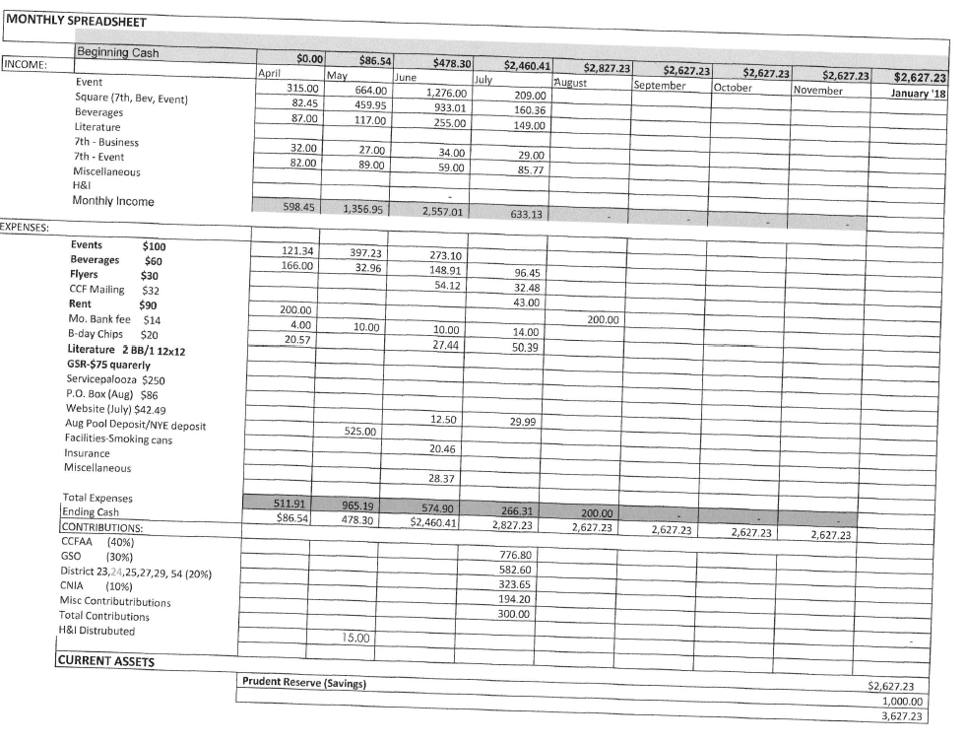
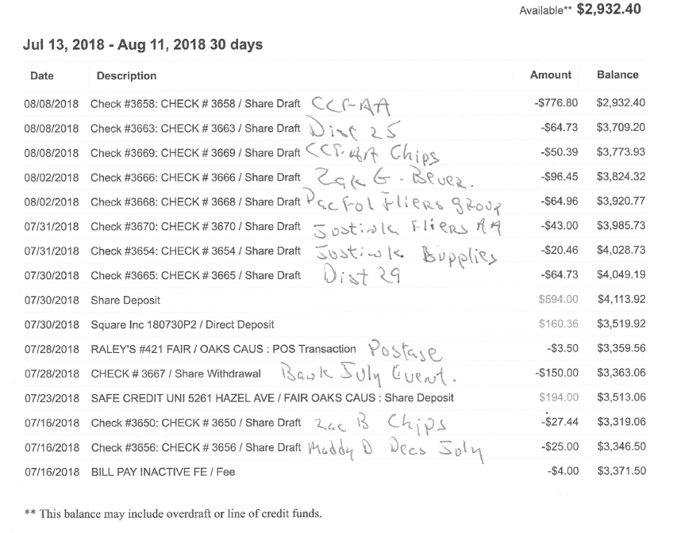

Secretary (Emily L): If this is your first time here and you would like to be a member of this group, please see me during the break or after the meeting so I can get your contact information. Don’t forget to send me your reports.

Facilities (Rachel C): I’ve been trying to get ahold of Shatara to schedule the group inventory. I’ll call again on Monday. Other than that, nothing to report. We’ve let St Marks know we’re not using the church this month. Do we need a paper contract? Does Clunie do that?
- Zak: they don’t. just keep your emails

Events (Justin): Hey family,

Things are groovy in Events land. Thanks for everyone who showed up to the subcommittee at the Chicken Coop.

We’re going to need volunteers for our float to pump up tubes, drive people up to sunrise after the meeting and chill/grill at the park whilst everyone is floating. I am passing around sign up sheets right meow. Also, if anyone has access to electric pumps for the tubes, please put those down on the list as well.

We will be having a subcommittee meeting soon to make sure everyone’s on the same page for the event.

Thanks for allowing me to be of service. I love you all

Outreach (Josh): Outreach things are going fine. So far we have Orange County YPAA co hosting the float. Working on getting a couple more co hosts. Lets try to get to 1000 invites on the event page. SOCALYPAA asked if we wanted to take a marathon meeting at their conference in November. I’ll put up a poll on the committee page.

Programs (Janessa): Hello. Our speaker for July was awesome and had a great message for YPAA and General Service. This month Marissa S. will be speaking at our river float event and that should be lit af. Cameron and I are off the hook for September, due to Servicepalooza, but we have some pretty neat stuff coming up for October and November. Cameron will be setting up panel speakers for October’s event, the panel will be on scary topics related to AA and recovery. I’ll be setting up panel speakers for November’s event. The panel will be on step 11, meditation, god and all spiritual things. I’m super excited to switch things up a bit and I totally dig everyone’s suggestion. So please keep em comin. Love you all. Thank you for allowing me to be of service.
Bylaws (Cait): nothing to repot
Beverages (Zak G): not too much to report on the beverages front. Seems like people really enjoy energy drinks so I’ll make sure to stock up on them for the river float event. Another popular item was water. I’ll be sure to have lots of that for the float as week. I went to smart and final today to get drinks for our next event which is the river float. We still have lots of soda and some energy drinks in stock from the last event. I will not be at the river float event so any questions you have for that you can ask my trusty co beverages chair Mr. Jason. By the way if I haven’t said it in my report already -- river float. Thank you for allowing me to be of service especially in buying drinks for the river float.

Graphics (Tucker): got the float flyers made and submitted to the BTW on time. Missed the deadline for Service palooza. Going to appeal that with them tomorrow. I need all information by the first of the month so I have at least ten days to get it made, submitted to the BTW and printed. Perhaps co-chair can help. I feel rushed to get them done and they don’t reflect my best work.
- Sam: how much time is needed?
- Tucker: usually a month in advance to get the information. It doesn’t take the full month but a couple weeks is good. Deadline for the BTW is the 10th of the month so I like to get info by the first

Literature (Sheila): sorry I missed the event last month and thank you for all the support. If you need to get ahold of me please call me/text me. I have stuff for new business

Webmaster (Emily G): nothing to report

GSR (Bryn): Area 7 Report 7/21/2018 from 11am to 1pm
Thank you for the feeling of being the new kid in class, fortunately I worked Up enough courage to walk through the door.
*Bring Flyers of SACYPAA future events.
Announcements on delegates that have fallen ill and could use some help.
Made announcement representing SACYPAA and bombed it!
Assembly reports - looks like we are under budget.
Miniprasa - report on venue. Cost for the whole weekend $450.
Winter Assembly - venue report.
Pre conference assembly - report on chairs, no waste conference.
Post conference assembly - Venue Report.
***Just spaced out and not sure what just happened***
June minutes approval - approved
Liaison Reports
H&I - handinorcal.org
Expanding to other facilities, homeless shelters etc.
CCFAA - picnic report.
NCNIA - super lost on this one, something about ice cream in Fresno in August, besides that lost.
NCAA - NorCalAA.org for a Bid app.
*food for thought how about SACYPAA hosting a non YPAA conference in the future.
YPAA report - bombed it!
Latin Women in AA Work Shop - August 4th in Richmond CA.
*Bring 7th tradition.
District – reports

Also, Service palooza is coming up and I need help planning. We’re having a meeting at Justin/Paige’s and I’ll post about that on the FB page. Wednesday 15th at 6 PM.
- Cait: did we get something generic in the BTW for Sept?
- Tucker: no, I’m sending it in tomorrow

Prayer/Unity (Braden M): next 4 weeks are very busy for our committee so I will be shooting for a late Sept early Oct date for our next unity event which I’m thinking a corn maze event out in the Natomas area.

Greeter (Jenna): Everything going well. I was unclear about the designated smoking area at last month’s event, so I apologize if that wasn’t in order. I guess I’ll need clarification for future events at St Marks. I won’t be at the Float WM event unless I can get my shift covered, but I will recruit greeters for it. Thank you for letting me be of service. Where will the greeters be for the float? The park, I assume? How should greeting work?
- Rachel: just have them by the meeting area when people are walking up
- Richard: you may want to have someone/ones at the exit point of the river so people don’t float past where they need to be
CCF (Camille): not here - I’m not sure how this report is supposed to be formatted but I attended the CCF meeting July 21st at 2:00pm for the educational portion on what a CCF delegate is and how I can contribute to the meetings.
The actual CCF meeting began at 3pm and was initiated by everyone introducing themselves and all of the events coming up for each group.
The annual CCFAA picnic is coming up Sunday, August 19th at Elk Grove Park from 9am-4pm. At this event there will be a speaker at 10am and at 2pm.
Citrus Heights Group 58th anniversary potluck and speaker meeting Wednesday, August 15th 6:30pm at the Lutheran Church of Ascension.
Lastly, NCCAA 71st conference coming up October 5-7, 2018 in Fresno, Ca.
This was followed by opening the meeting to new groups that were aspiring to be official. Those groups were “The Drunk Squad” and another new meeting in Colfax, Ca. We voted the new meeting in Colfax in and the Drunk squad will be voted in at another time that is unknown.
Next we discussed CCFAA website which we are now trying to properly configure our email for aasacramento which has been successfully worked on by Josh R. from aa San Jose. Lastly, we talked about Teleservice and their need for volunteers to provide 12 step work for those in need.
The meeting closed at around 4:30pm.
Let me know if you need further information from me on this report.
Thank you for letting me be of service.
H&I (Adam J): Attended the monthly meeting which is now at Mimi’s not Denny’s. All is well.
PI/CPC (Sandra M): showed up to the listed PI CPC meeting, but no one else was there. Emailed the chair and got no response. My co-chair Alex found out about a join inventory meeting of general service, H&I, PI CPC at North Hall on the 19th so we’ll be attending that. Thank for allowing us to be of service and hopefully we’ll have an update next month.
Bid Chair (Paige M): things are happening. Come to Summit.
- Eddie: When is Summit?
- Rachel: Nov 2-4 in Visalia
Birthday Chair (Zach B): birthdays are good nothing to report.
Communications (Maddy): Communications are great. Please let me know if you’d ever like to be removed or re-added to the group text. If you are not receiving group texts currently it may be because at one point you requested to be taken off. If anyone would like a group text sent out at any time, please just let me know (typically they are sent out day-of any meetings or events). Thank you for the opportunity to be of service guys! Also please don’t delete things on the calendar, because it deletes it from everybody’s calendars
Fellowshipping (Robby C): nothing to report
Inreach (Rachel S): nothing to report. Let me know if you know of any meetings that are struggling. I’ll like to plan a meeting bomb next week
- Maddy: what happened to the game?
- Rachel: I do but my computer isn’t working so I just need to compile the info and get this ready for the next business meeting
Open Forum
- Ada: Katie H reached out to me as she’s going to NY and will be bringing feedback about the YP pamphlet. Would we will willing to have her at the business meeting and have her gather feedback on the pamphlet
  - Cait: she’s an appointed committee chair
  - Bryn: I think that’s a good idea. Let’s do it
  - Ada: I’ll add it to the agenda next month and post anything ahead of time that Katie wants to me to post
- Rachel C: CCF picnic is next Sunday at 9 AM – 4/5 PM ish. If you’re interested in helping at the YP booth for the silent auction we really need help. Also if you’re interested in being of service to the juvenile detention center Jacob C is looking for volunteers. Application, background check, etc. so I’m assuming you can’t have felonies but if you’re interested let me know.
- Armando: 1) Main YP meeting on Saturday at spring fling if you have a recommendation for the 10-minute speaker let me know. 2) please go to your YPAA groups and see if they want to be readers/secretary for the Saturday meeting at spring fling
- Justin: I am now EBYPAA’s safety chair so I’m charge of parking and security at Yuba. Unless you’ve rented a cabin, are a speaker, or will be of service as a shuttle driver for 3-6 hours, you can’t park on site. There are 2 parking lots 5 minutes away and we’ll have shuttle drivers around the clock. If you want to park onsite and help the committee, please fill some shuttle and security shifts. Passing out a signup sheet.
- Ada: who is going to the 10 PM meeting that can take the lead? Saturday 10 PM
  - Will was volunteered
- Josh: I just wanted to say that Sacramento YPAA is hella wholesome and we’re really blessed. Also I have flyers in my car. Love you guys
- Eddie: last month we voted in the LGBTQ chair. If we’re trying to be inclusive we have 2 communities in Sacramento that aren’t really included: natives and Spanish speaking. Do we as a committee want to add outreach to those communities?
  - Bryn: what is the LGBTQ chair position description?
  - Armando: inreach but for that community
  - Rachel C: does anyone speak Spanish?
  - Sandra: hi.
  - Rachel C: we’d need someone that speaks fluent Spanish
  - Cait: me Zak and Sandra can do it
  - Bryn: I think that’s a good idea Eddie. I also don’t understand why we need a chair for that though. When I was inreach for WACY I just assigned that for them to do. Our increach could do that
  - Paige: there’s frequently people here that want positions and then we don’t have them.
  - Rachel S: Inreach is everyone’s job. We can do that now and assign people but it’s too much for just me. Do we need a specific chair for that? I don’t necessarily think so. It’s just a matter of us doing it
  - Will: We’re just talking about Native American AA right? Not their other recovery groups?
  - Group: yes
  - Rachel C: I think it’d be nice to have a newcomer come in and be able to take that position. This can be discussed in a bylaws subcommittee
  - Cait: I’m not hearing enough interest right now to hold a subcommittee on it. If you feel strongly come talk to me
Old Business
- None
Elections
- Co graphics: John
- LGBTQ chair: Chase
New Business

- Sheila: newcomer packets are $1 and only includes a few packets and a small phone list. Do you guys want to make our own phone lists and have them printed? How many packets should we have per event? Do we want to add any different pamphlets? I need help brainstorming and then I can propose a budget.
  - Group: let’s make our own phone list
  - Richard makes a motion to give Sheila a budget of $50 for the next month. Zach seconds.
  - Discussion:
    - Rachel C: do we want to do a subcommittee on this?
    - Paige: I’ll post on the page what the newcomer packets currently have
    - Sheila: I’d like to get something for this next event
    - Bryn: I don’t know if this is an ideal event to have packets at because we’ll be floating
    - Richard: let’s just do $50 and trust our trusted servant
    - Vote: 1 abstain, 1 opposed. Minority opinion: Bryn – I think she may need more money. This changes someone’s mind and revote is taken. Revote – 24 in favor, 2 opposed, 2 abstain. Motion passes
- Rachel C: we have fires in Redding, Shasta County, Mendocino. A lot of us came together to help Santa Rosa. Maybe we can reach out to the current places with fires to see what they need and help.
  - Adam: I can reach out to those in Mendocino
  - Sam: I’ll reach out to Redding, I’ll be up in that area

Announcements
- Zak: Goon Squad is moving to 21st and J
- Armando: 12 x 12 at SNC tonight
- Eddie: Jan 3-6 WACYPAA Boise, Idaho. End of December we should see cheap flights with Southwest
- Josh: ICYPAA is at the end of this month, a bunch of us are going Aug 30-Sept 2. Norcal bid has our last business meeting end of this month. I’ll keep you posted on elections for next year.
- Paige: if anyone is going to ICY, ACY would appreciate help with getting pre-regs. I’m going to lunch with group inventory facilitators beforehand, if you want to come let me know
- Cait: Sat Sept 1 YOLYPAA is having a speaker meeting where Davis YP is and then big book trivia end of the month
- Justin: Yuba is next weekend
- Ada: don’t forget about the group inventory. If we need a second session we can plan that. We’ll also have a follow up meeting.

Meeting closes at 2:27.

First time here: Chase, Kim, Tyler S, John P

